DC DEPARTMENT of HUMAN SERVICES
Adult Protection Services (APS)
FY16 ANNUAL REPORT

DC DEPARTMENT of HUMAN SERVICES
Adult Protection Services (APS)
FY16 ANNUAL REPORT

Message from the Director

The Adult Protective Services (APS) division investigates allegations of abuse, neglect, self-neglect, or exploitation of vulnerable adults and provide services to stop and/or prevent further abuse. An APS investigation is a multi-faceted process that requires client assessment, mitigation of any emergent risk and service provision to achieve and maintain safety and documentation of key findings, results and safety plans.

The APS program saw several successes in FY16. Building on the 2015 accreditation received from the Council on Accreditation, APS was awarded their first ever competitive grant award from the U.S. Department of Health and Human Services Administration on Community Living. This funding will assist the APS team with implementing a comprehensive national reporting system to collect data on abuse, neglect and financial exploitation.

APS is also streamlining and re-engineering the existing investigative process by using a Structured Decision Making (SDM) model. This entails a suite of assessments to promote safety and well-being of our clients.

In addition, APS continues to partner with a number of agencies and organizations in the District to increase awareness and encourage reporting. While we don’t seek an increase in cases year-over-year, we want to ensure District residents know APS is a resource available to them. This has contributed to the number of investigated cases rising significantly from the previous year – from 921 in FY15 to 1485 in FY16.

Many challenges lay ahead. As the Baby Boomer generation ages, we are seeing increased allegations across the board. This is especially true for financial exploitation: in Fiscal Year 2016, APS made 20 referrals to the Metropolitan Police Department with potential losses to older and vulnerable adult victims of more than $6 million dollars. Subsequently, DHS implemented the Senior Safe program with the Department of Insurance, Securities and Banking to reduce financial abuse of seniors.

We are proud of the compassion and diligent work of the APS staff to address this challenging work and provide effective service to our clients and partners.

Laura Green Zeilinger
Director
Department of Human Services

Table of Contents

Introduction 3

Adult Protective Services-Purpose and Organization 3

Operating Budget
Staffing and Division Composition

The Work of Adult Protective Services 7

Population Served
Hotline Operations
Review, Evaluate and Decide
Structured Decision Making
Brief Summary of Client Data
Complexity of Client Health Status
Hoarding Disorder

Data Tracking, Findings and Discussion 9

Referral Source and Reporting 17

Program Outcomes 18

Legal Intervention 18

Service Provision 20

Interagency and Community Collaborations 21

Senior $afe……………………………………………………………………………………… 22

Vulnerable Adult Fatality Review Board 24

Information, Education and Community Outreach Presentations 25

Agency and Community-Based Committee Affiliations 26

Agency and Community-Based Committee Affiliations 27

Appendices 28

Introduction

The District of Columbia Department of Human Services (DHS), Family Services Administration (FSA), Adult Protective Services (APS) Division provides social services and crisis intervention to address the needs of abused, neglected, self-neglected, and exploited vulnerable adults (18 years of age and older). The primary goals of APS are to mitigate immediate risks and promote the safety and well-being of vulnerable adults.

The Fiscal Year (FY) 2016 APS Annual Report provides a discussion of the reports of abuse, neglect, self-neglect and exploitation of vulnerable adults both received and investigated by the division. In addition, this report identifies the aggregate outcomes of case investigations and illustrates the extent to which APS collaborates with multiple agencies to mitigate risks, provide services, and stabilize vulnerable adults.

Adult Protective Services – Purpose and Organization

APS investigates reports of alleged abuse, neglect, exploitation, and self-neglect of vulnerable adults. Further, APS intervenes to remediate risk when reports are substantiated in accordance with the Adult Protective Services Act of 1984, effective March 14, 1985 (D.C. Law 5-156; D.C. Code §§ 7-1901, et seq.), as amended (Act) and its accompanying regulations located at 29 DCMR §§ 2900, et seq.

In non-life threatening emergencies, APS initiates an investigation within ten (10) working days of receiving a report of abuse, neglect, exploitation, or self-neglect. If a case involves the risk of immediate and life-threatening harm to an individual, APS is required to contact the Metropolitan Police Department (MPD) and begin its investigation within 24 hours. These two (2) investigations can be initiated simultaneously.

APS is required by statute to have the capacity to receive reports 24 hours a day, seven (7) days a week. APS accomplishes this requirement through its hotline where the caller has the ability to speak with a “live” person. To this end, APS has a cadre of social workers who work on-call to ensure referrals are assessed immediately and proper execution is exercised.

Operating Budget

The operating budget for APS in FY16 was $2,647,089 ($2,034,659 in local funds and $612,430 in federal funds). Federal funds originate from the Social Services Block Grant (SSBG), which is awarded by the U.S. Department of Health and Human Services (DHHS), Administration for Children and Families (ACF). SSBG provides federal financial assistance to states for the provision of services that assist families and individuals achieve economic self-sufficiency, prevent or remedy neglect, abuse or exploitation of children or adults, and preserve families by preventing institutionalization.

Structure and Operations

APS conducts its work through four service clusters: the Screening Services Cluster (SSC), Intake Services Cluster I and II (ISC) and the Continuing Services Cluster (CSC). Each cluster consists of a supervisor who provides guidance and direction to the cluster and social workers.

Screening Services Cluster

This cluster is staffed by a licensed clinical social worker and two supporting licensed social workers who receive referrals, document the information electronically and submit the referral to the Review, Evaluate and Decide (RED) team to determine the extent to which the information provided by the referrer can be investigated as one of the four allegation types (i.e., abuse, neglect, self-neglect or exploitation) based on uniform criteria. In terms of oversight, this process is executed through the ISC Supervisor. The SSC Screening social worker obtains as much of the following information as is known by the person making the report:

- The name and location of the adult and directions to the adult’s place of residence;

- The names and relationships of other members in the household;

- The age of the adult;

- The alleged incapacity of the adult, if warranted;

- The name and address of the caregiver, if any;

- The circumstances surrounding the abuse, neglect, exploitation, or self-neglect and/or the reason(s) the reporter suspects the adult is at risk of abuse, neglect, exploitation, or self-neglect;

- Whether an emergency exists;

- The name of witnesses, including their telephone number(s) and addresses;

- Any information about previous abuse, neglect, exploitation, or self-neglect;

- The name, address, and relationship of any other person(s) or agencies that might be concerned or have knowledge of the adult;

- The living arrangement of the adult (e.g., they live alone, with their spouse, with the alleged perpetrator, etc.);

- The name, address, and telephone number of the person reporting if the reporter is willing to give this information;

- Source of the reporter’s information;

- Any other information that might be helpful in establishing the cause of the suspected abuse, neglect, self-neglect, or exploitation or the risk of abuse, neglect, self-neglect, or exploitation;

- Permission to give the reporter's name and telephone number to the appropriate regulatory authority; and

- The adult’s income and other resources, if known.

Intake Services Cluster

The Intake Services Cluster (ISC) comprises of the front-line responders who explore the extent to which the referred allegation is substantiated or not, based on the fact gathering during the case investigation process. It is incumbent upon the Intake Services Social Worker to mitigate any emergent risk(s) and if needed, make the appropriate recommendations to the Continuing Services Cluster for additional follow-up where necessary.

Continuing Services Cluster

The Continuing Services Cluster (CSC) investigates cases received from ISC that require additional attention. These cases remain within this cluster until the risks to the vulnerable adult have been mitigated or remedied.

To achieve this goal in the best interest of the client, CSC social workers may link the client with community agencies for assistance, provide homemaker services, place a client in a safe place, as well as provide food if the client is in need and/or lacks the ability to obtain food on his or her own. Social workers in this cluster are required to conduct follow-up assessments until the case is closed.

Staffing and Division Composition

APS consists of the following personnel: the APS chief; three supervisory social workers; fourteen social workers; two social service assistants, and a program/policy analyst.

Cluster/Unit | Role | Full Time Equivalent
Office of the Chief | Chief, Ph.D., MBA | 1
 | Program/Policy Analyst | 1
 | Social Services Assistant | 1
 | Social Services Assistant | 1
Screening Cluster & Intake Services Cluster I | Supervisory Social Worker | 1
 | Social Worker | 5
Intake Services Cluster II | Supervisory Social Worker | 1
 | Social Worker | 4
Continuing Services Cluster | Supervisory Social Worker | 1
 | Social Worker | 5
 | Social Worker (vacant) | 1
Total |  | 22

Staff In-Service Trainings and Workshops

APS staff participated in three (3) in-service trainings and workshops including the following:

- Behavior Symptoms Management Training, conducted by The Alzheimer’s Association (October 16, 2015);
- Office of the Attorney General for the District of Columbia (OAG), Office of Consumer Protection (April 22, 2016); and
- The Use of Health Homes to Better Meet Client Needs, Department of Behavioral Health (September 16, 2016).

Continuous Quality Improvement Team

The APS Continuous Quality Improvement (CQI) team, comprised of eight (8) APS staff, represents a cross-section of the management team and each of the four (4) service clusters (SSC, ISC I, ISC II and CSC staff). The team continued its work during the fiscal year with four (4) overarching goals guiding their work: (1) ensuring high quality of service; (2) identifying improved/best practices for APS work; (3) determining strategies for improving compliance standards, mandates as well as regulations; and (4) assisting in meeting APS’ annual goals and objectives using a theory-based management system that focuses on processes, feedback and outcomes.

Much of the CQI team’s work, as well as that of APS during this fiscal year, has revolved around the customization of four (4) assessments (Strength and Needs, Response Priority, Safety and Risk), which are currently being field-tested for implementation. These evidence-based assessments assist in decision making at critical points in a case investigation. Three assessments (Strength and Needs, Response Priority, and Safety) will be implemented by the end of FY17. The Risk Assessment is expected to be implemented by January 31, 2018.

Council on Accreditation (COA)

COA is an international, independent, not-for-profit, child-and-family-service and behavioral healthcare accrediting organization. Earning this accreditation increases the credibility, integrity, and achievement of APS. The accreditation facilitates the streamlining of program standards, policies and procedures. This accreditation also signals the program’s commitment to offer the optimal services to its clients.

Since receiving COA accreditation, APS in conjunction with the CQI team has begun to address the action steps required for reaccreditation consideration. As such, APS competed and was awarded grant funds from the U.S. Department of Health and Human Services, Administration on Community Living, as a Tier 1 grantee to implement promising practices that will streamline and enhance current operations while creating the ability to report data to the National Adult Maltreatment Reporting System (NAMRS).

National Adult Maltreatment Reporting System

The National Adult Maltreatment Reporting System will be the first comprehensive, national reporting system to collect data on adult abuse, neglect and financial exploitation from APS programs. NAMRS will collect quantitative and qualitative data on the practices and policies of adult protective services (APS) agencies and the outcomes of investigations into the maltreatment of older adults and adults with disabilities. The absence of data for research and best practice development has been cited by numerous entities, including the Government Accountability Office, as a significant barrier to improving APS programs. Policymakers, APS programs, and researchers will use the data to evaluate and improve programs.

The goal of NAMRS is to provide consistent, accurate national data on the exploitation and abuse of older adults and adults with disabilities, as reported to APS agencies. NAMRS is an annual, voluntary system to collect both summary and de-identified case-level data on APS investigations, agency component and key indicator data.
The District’s Adult Protective Services was one of eight jurisdictions competitively selected to be in the first cohort of grantees to streamline existing data collection strategies in an effort to submit information to a national repository. The information will include an agency component, case component and key indicator data.

The Work of Adult Protective Services

Population Served

APS provides services to any District resident who is 18 years of age or older and is:

- Highly vulnerable to abuse, neglect, exploitation, or self-neglect because of a physical or mental impairment;
- Being or has recently been abused, neglected, exploited by another, or is a victim of self-neglect; and
- Likely to continue being abused, neglected, exploited by others, or engage in self-neglecting behaviors.

Hotline Operations

In FY16, APS received 3,728 hotline calls. Of this number, 1,485 referrals resulted in case investigations. The remaining calls (2,243) were referrals submitted to the Review, Evaluate and Decide team that did not meet the eligibility screening criteria required to elevate the referral to an assigned social worker for case investigation or referred to a more appropriate agency or external partner to respond to the inquiry based on the nature of the call.

Review, Evaluate and Decide Model

In December 2014, APS implemented the Review, Evaluate and Decide (RED) model. The RED model consists of a team of seasoned APS social workers and managers, who meet daily to review, evaluate and decide on the APS referrals that should be screened for emergency or non-emergency action; make case assignments to an APS social worker; and screen out case referrals that do not meet the APS criteria for investigation. Introducing the RED model provided the opportunity to embrace a team approach for reviewing all referrals submitted to APS. The RED model facilitates team collaborative processing of information based on the circumstances of each referral. The RED model has assisted the APS team in acclimating to a systematic approach for reviewing, discussing and deciding the extent to which a referral alleging abuse, neglect, self-neglect, and financial exploitation is appropriate for APS investigation based on established criteria.

To this end, the APS team has developed a set of decision processes that has facilitated full integration into the existing operations and infrastructure. Adding the RED team approach to the APS practice is preparing the team for full implementation of the Structured Decision Making Model by the end of calendar year 2017.

Structured Decision Making

The Structured Decision Making (SDM) Model is a research-based risk assessment that provides (1) an evidence-based strategy for determining client risk; (2) a better assessment and triage of referrals; and (3) improved data that can be used to better identify services and resources to meet the need of the vulnerable adult. Implementation of the SDM model will be beneficial in assisting APS staff in obtaining consistency and integrity when making decisions at critical points in a case investigation.

Complexity of Client Health Status

Concurrent with aging is the propensity for increased compromised health that can lead to a decline in health status. This is very evident in the client profile of cases investigated in FY16. As such, the vulnerable adults who were the subject of the referrals investigated by APS had a wide variety of chronic illnesses. APS clients reported more complex medical and behavioral health concerns/issues. For example, in FY16, seventy percent (70%) of the clients referred were identified with at least one chronic health issue (e.g., arthritis, stroke, hypertension, high blood pressure, diabetes, cardiovascular and other related heart diseases, etc.) compared to FY15 which was (60%). Within this group, nearly half reportedly had co-morbidities (more than one chronic illness). Forty-five percent (45%) of these same clients had a diagnosis or were assessed for dementia or other memory loss diseases; sixteen percent (16%) had mental/behavioral health illnesses (e.g., schizophrenia, depression, paranoia, etc.); one percent (1%) had visual and/or hearing loss; two percent (2%) suffered from substance abuse (alcohol or illicit drugs); and three percent (3%) had other health problems (e.g. HIV/AIDS, ambulation problems, etc.).

- Chronic Health Problems and Dementia: Chronic health problems are the most prevalent health issue reported for clients active in APS. The most frequent conditions reported were dementia and Alzheimer’s disease.

- Mental Illness: Mental illness impacts a significant number of clients referred to APS. This has led to the need for increased collaboration with the Department of Behavioral Health (DBH) which includes their Mobile Crisis Services/Comprehensive Psychiatric Evaluation Programs.

Hoarding disorder is a persistent difficulty discarding or parting with possessions because of a perceived need to save them. A person with hoarding disorder experiences distress at the thought of getting rid of the items. Excessive accumulation of items, regardless of actual value, occurs.

Hoarding has emerged as one of the major contributing factors with regard to self-neglect referrals. Compulsive hoarding creates a risk of excessive clutter, deplorable living conditions, sometimes increased risk of fire, personal injury and/or the threat of eviction. Given the complexity of hoarding cases, APS staff engaged in specialized training on Hoarding Disorder as presented in The Diagnostic and Statistical Manual of Mental Disorders (DSM-V) revised in 2015.

APS staff currently uses the Frost Hoarding Assessment tool, developed by Randy O. Frost, a respected hoarding scholar. This evidence-based tool was designed to achieve three (3) objectives: (1) assist the investigator in determining whether a situation meets the criteria of hoarding; (2) determine and implement appropriate strategies for addressing the safety risks (e.g. heavy duty cleaning, pests and vermin infestation); and (3) collaborate with the community network to provide ongoing case management and oversight.

The APS social worker uses a complimentary hoarding scale to the Frost Hoarding Assessment tool that identifies the severity of the hoarding on the basis of four (4) levels. The information collected from this assessment, as well as pictures obtained during the home visit, are compared with the National Study Group on Chronic Disorganization (NSGCD) Clutter Hoarding Scale. The use of this scale is a guide for the assessment of the home interior, which includes household functions (good housekeeping functions), structure and zoning (accessibility of doors, stairs and windows), health and safety, as well as appropriate animal control.

Data Tracking, Findings, and Discussion

APS staff continues to enter and track key data elements related to client referrals and investigations using the QuickBase software application. This is a web-based data management platform that provides data in “real time.” APS uses the database for entering and maintaining case specific information that illustrates important demographic information and data outcomes as it relates to elements such as frequency of allegation type, ward, age, gender, etc. The FY16 statistical data and information presented in this report are extrapolated from the APS database. The discussion herein is an aggregate presentation of the critical data elements that address program outcomes and efficacy. The information is based on case investigations (1,485) during this reporting period. This is a significant increase from FY15 (921) of over 500 case investigations.

Brief Summary of Client Data

In FY16, APS investigated more cases involving women (868) than men (617). These numbers are indeed higher than FY15 cases involving women (558) and men (363).

Overall, the FY16 findings suggest the largest numbers of referrals that resulted in case investigation by age category were 18-59 and 80-89.

With regard to allegation type, neglect emerged as the predominant reason for case investigations among persons in age categories: 18-59 (107), 60-69 (77), 70-79 (98) and 80-89 (116).

Cases by Allegation Type

In FY16, the highest percentage of cases investigated (32%) were allegations of neglect. This represented 468 cases. This was closely followed by self-neglect (29%) which attributed to 424 case investigations. Of this number, 280 cases were identified as hoarding. Exploitation comprised twenty-two (22%) percent of the cases (333) investigated in FY16, which is an increase in exploitation cases investigations from FY15 (220). With regard to abuse, there were 260 case investigations. Overall, this represented eighteen percent (18%) of the cases investigated in FY16.

Cases by Age Category

Of the 1,485 cases investigated during FY16, twenty-three percent (23%) or 338 cases represented persons in age category 18-59. Interestingly, case investigations for persons in age category 80-89 closely followed at twenty-two percent (22%) or 328 cases. Case investigations representing persons in age category 70-79 comprised twenty-one percent (21%) or 314 cases. Persons in age category 60-69 represented nineteen percent (19%) or 282 of APS’ total case investigations. The remaining five percent was considered missing data because the client declined to either provide his or her birthdate or age in years,

Cases by Ward

Figure 1 illustrates the number of investigated cases by ward. The largest number of cases that were investigated in FY16 occurred in Ward 8 (266), followed closely by Ward 5 (260). As the pie chart further shows, the investigation totals in Ward 4 was (231), Ward 7 (214), Ward 6 (156), Ward 1 (132), Ward 3 (97), and Ward 2 (95). The remaining cases were treated as missing data because either the subject of the investigation no longer resided at the given address as indicated in the referral or the individual moved out of jurisdiction.

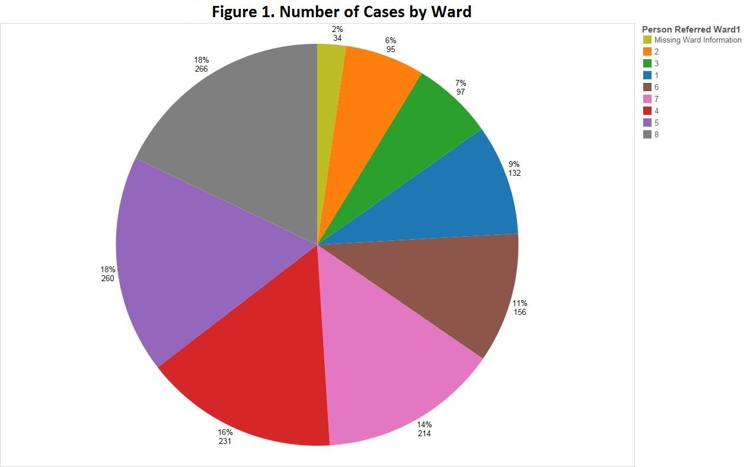
Source: APS Database
Note: Thirty-four cases omitted because either the subject of the investigation no longer resided at the given address as indicated in the referral or the individual moved out of jurisdiction.

Age Category by Ward

Figure 2 indicates that the greatest number of cases investigated across all age categories was for persons in age category 80-89 (289). This is nearly one-fifth of the total cases (1,485) investigated in FY16. The largest number of these case investigations in this age category occurred in Ward 8 (80). Persons in age category 70-79 represent the next highest (267) age category. In this age group, Ward 7 reflects the most persons who were the subject of an APS investigation. The age category 60-69 (253) closely followed with the highest number of case investigations involving individuals in this group occurring in Ward 8. Although not one of the highest three age categories, there was an increase of cases in persons in age category over ninety (90) from FY15. In FY15, the number of case investigations involving persons over ninety (90) was 88 compared with 133 in FY16. Cases for this age category have shown to be highest in Wards 4 and 5, for both FY15 and FY16.

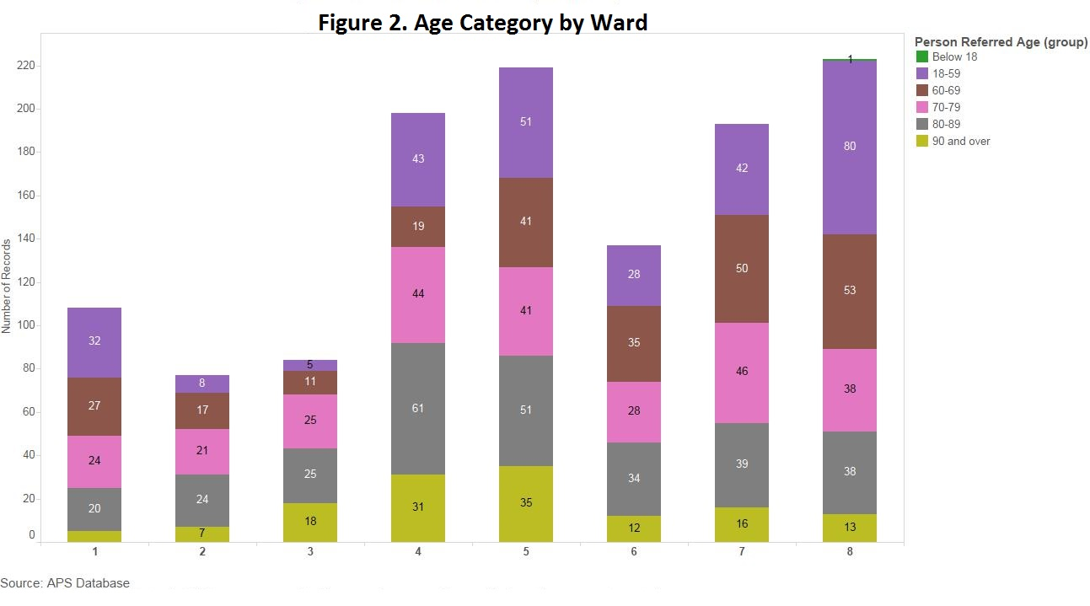

Allegation Type by Ward

Figure 3 reflects that the most frequent allegation referred in FY16 by ward is neglect, closely, followed by self-neglect. This was the finding in all the wards, with the exception of Wards 2 and 3. With regard to the remaining two (2) allegation types, that is, cases involving exploitation and abuse, financial exploitation cases investigated were highest in Ward 5. Abuse was highest in Ward 8.

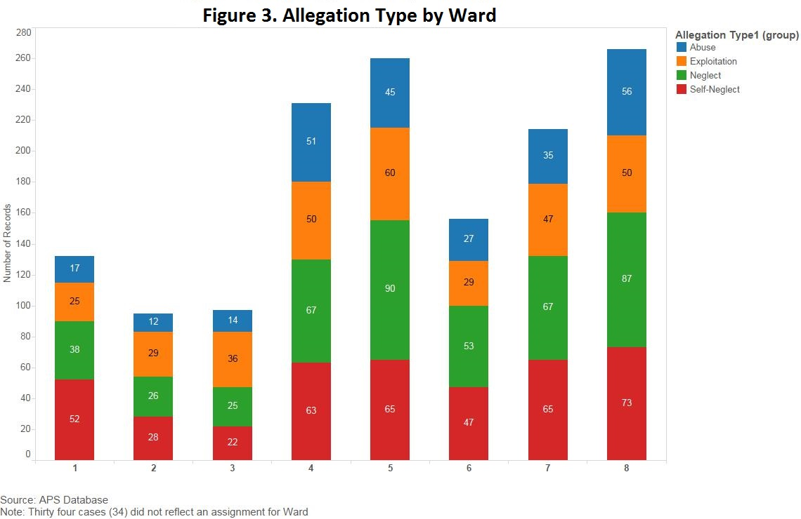

Allegation Type by Gender

Figure 4 illustrates that of the cases investigated in FY16, each of the allegation types were highest among women.

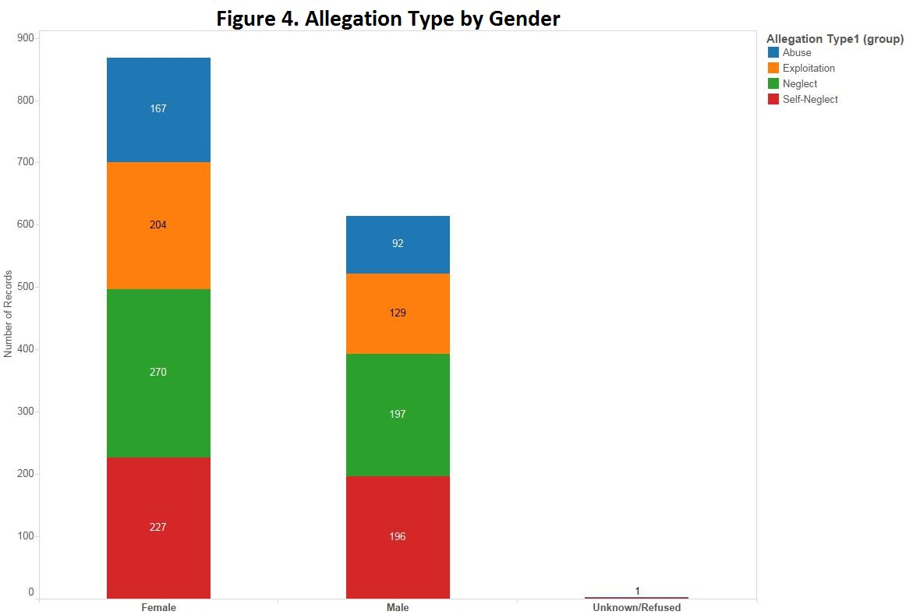

Source: APS Database

Allegation Type by Age Category

Figure 5 reflects in FY16 that the highest allegation type investigated was neglect across all age categories, 18-59 (107), 70-79 (98), and 80-89 (116), with the exception of those reported in the age group 60-69. In this age category, self-neglect had the highest case investigations (101). The data undoubtedly show differences compared with FY15, where self-neglect was the most prevalent allegation type for the age categories 60-69 (49), 70-79 (53), and 80-89 (70). Neglect reportedly was highest among females.

While the incidence of abuse, neglect and exploitation increased in FY16, self-neglect continues to emerge as a burgeoning issue, particularly related to hoarding. With this understanding, nearly two-thirds of the self-neglect APS investigations involved cluttering and/or hoarding.

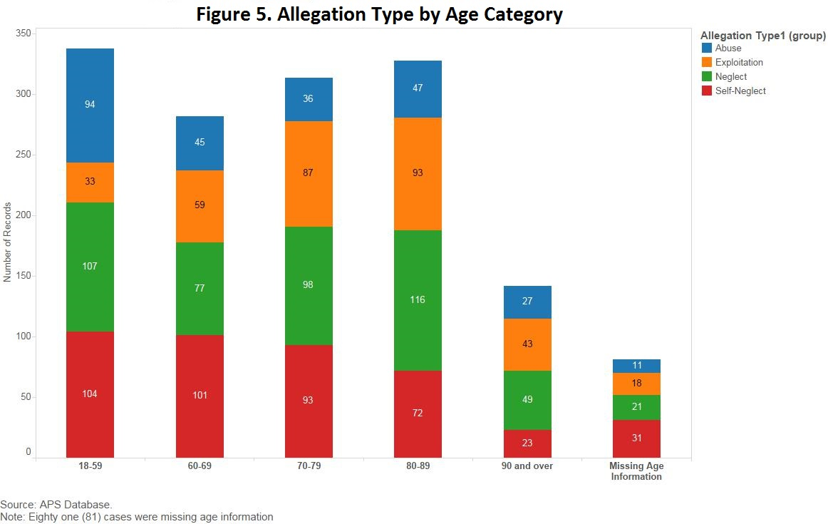

Gender by Ward

Data presented in Figure 6 suggests that similar findings were observed in both FY15 and FY16, and women represented the majority of these cases across all wards (513 women vs. 408 men). In FY16, there was a significant increase in the number of women who were the subject of an APS case investigation (851), and the number of men was 634.

Ward 8 had the highest number of men (114) and women (151) as the referred person. Just slightly behind was Ward 5, with 113 cases for men and 147 for women. Coincidentally, Wards 4 and 7 had the same number of men (91) who were clients of an APS investigation, while there were 140 cases involving women in Ward 4 and 123 cases involving women in Ward 7.

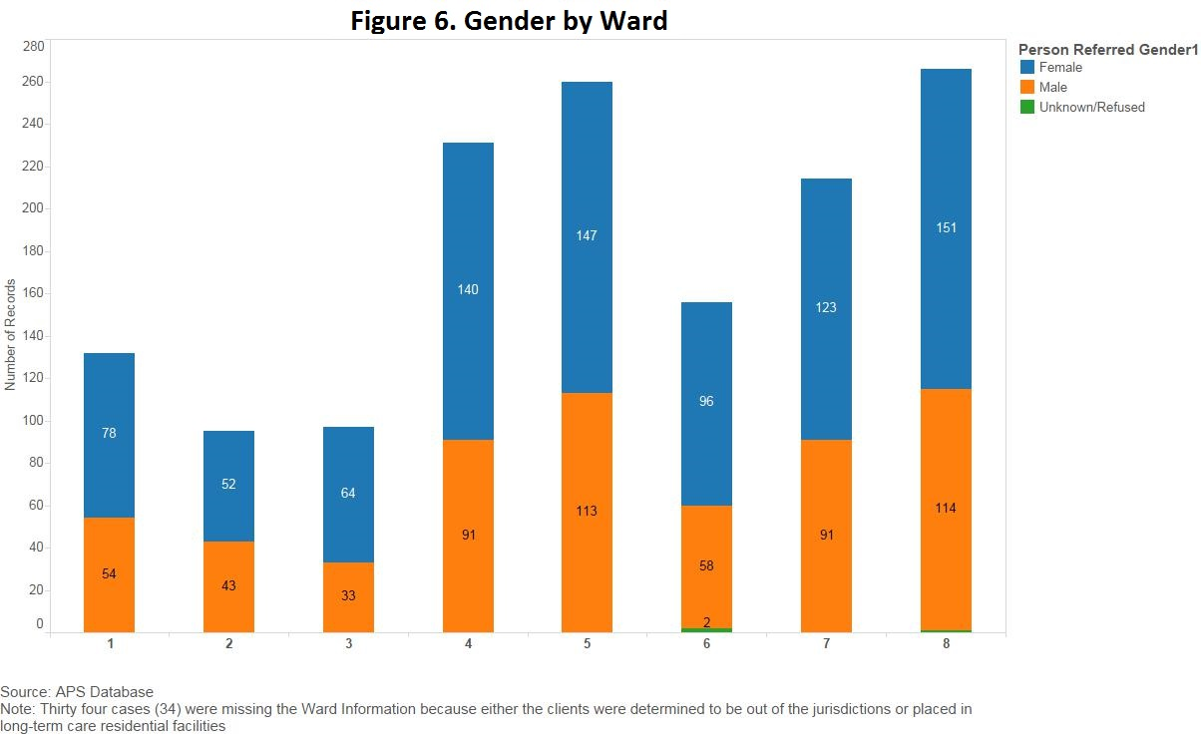

Referral Source and Reporting

Under the District’s APS statute, anyone can report instances of abuse, neglect, exploitation, and self-neglect. However, the law mandates that certain persons are required to report instances of abuse, neglect, or exploitation to APS unless a specific exception applies. Specifically, the Act states, in part,

“whenever a conservator, court-appointed mental retardation advocate, guardian, health care administrator, licensed health professional, police officer, humane officer of any agency charged with the enforcement of animal cruelty laws, bank manager, financial manager, or social worker has as a result of his or her appointment, employment, or practice substantial cause to believe that an adult is in need of protective services because of abuse, neglect, or exploitation by another, he or she shall immediately report this belief.” See D.C. Code § 7-1903 (a) (1).

Table 1 provides an overview of the referral sources and the number of referrals that resulted in APS opening investigations in FY16. As Table 1 indicates, the largest number of APS referrals (368 cases) originated from social workers who are mandatory reporters and case managers. The second highest number of referrals was received from individuals classified as other adult/non-relative (355). Persons in this category are comprised of those who desired to make a referral but requested anonymity. The third highest number of referrals originated from the Metropolitan Police Department (108) and bank fraud departments (91).

Table 1: Number of Referrals/Cases by Referral Source

Referral Source | Number of Referrals
Health Care Professionals | 69
Metropolitan Police Department | 108
Mayor’s Office | 4
Bank Fraud Dept. | 91
Family | 220
Friend | 121
Social worker/case manager | 368
Self | 36
Property Manager | 53
Home Health Agency | 24
Dept. Of Behavioral Health--Mobile Crisis Unit | 8
Fire Emergency Medical Services | 18
Residential Services Coordinator | 10
Other Adult/non-relative | 355
Total | 1485

Program Outcomes

The outcomes of APS investigations vary and depend on the unique circumstances of the individual assisted by the division. APS investigations result in the mitigation of immediate
risk(s), stabilization of individuals in the least restrictive environment, and the provision of resources such as caregiver support services, food, or other emergency assistance. For cases that require court intervention, APS collaborates with Office of the Attorney General (OAG) to petition the court for the appointment of a temporary guardian, special conservator, temporary guardian and special conservator, permanent guardian, or permanent conservator.

Table 1 identifies the services and the number of clients receiving each of the interventions that APS offers.

Table 2: Program Outcomes by Number of Clients

Outcomes | Number  of Clients
Total Remediated Risks | 1485
Referrals to Assistant Attorney General | 68
Guardian/conservator appointed | 60
Refused Services* | 45
Homemaker placement | 65
Psychological Assessments | 87
Safe Placement** | 2
Source: APS Database
*This figure primarily represents clients who are hoarders or have some level of dementia.
**Safe Placement removes an individual from an unsafe environment/condition.

Legal Intervention

Cases referred to court, reasons for referral, outcome, and associated costs.

Number of court cases: In FY16, sixty-eight (68) referrals were made to the Office of the Attorney General for consideration to be filed as petitions for guardianship or conservatorship on behalf clients active in APS.

Outcomes: Of the sixty-eight (68) petitions filed, there were nine (9) emergency hearings that resulted in the appointment of six (6) guardians and three (3) conservators. In addition, fifty-two (52) appointments were made. This resulted in thirty-two (32) guardians, eighteen (18) guardian/conservators and two (2) conservators. The remaining cases were “not papered,” because the OAG Assistant Attorney General assigned to assist APS with guardianship and conservatorship cases determined the case lacked legal sufficiency to file for legal intervention with the court.

Reasons for referral: The clients were referred to APS because they were subject to or at risk for abuse, neglect, or exploitation. Guardians were sought when clients lacked the capacity to make decisions about their own care, specifically as it relates to medical care. Conservators were sought when the clients had assets and/or property and were unable to manage their finances related to their lack of decision-making capacity. Cases were referred to the Probate Division of the Superior Court of the District of Columbia (Probate Court) for purposes of obtaining the appointment of a guardian or conservator primarily for clients with dementia or Alzheimer’s disease who needed someone to make decisions for them.

Prior to scheduling a hearing, the Probate Court requires certain documentation to be included in each petition that is filed. The petition must include assessments completed by the APS social worker, a clinical psychologist, and the client’s physician or medical staff at a hospital. The petition must also include the names and contact information for all interested parties.

Associated costs to APS:

Costs associated with petitioning the court for a guardian and/or a conservator include:

- APS staff time to investigate the client’s situation, obtain medical reports, consult with OAG, and prepare the petition. The costs associated with APS case management services are a part of the APS operating budget, and therefore, are not calculated as an expense associated with petitioning for a guardian and/or conservator.

- Psychological evaluations at an average cost of $300 per case when services are requested.

DHS renewed its Memorandum of Understanding (MOU) with OAG for the representation of APS in all court cases seeking guardianship or conservatorship. The funding for the MOU was $60,000 for FY16.

The following guardian related costs are covered by the D.C. Superior Court Probate Division Guardianship Fund, unless the client has assets to cover the cost:

- A court-appointed examiner can cost $75 per hour.

- A court-appointed visitor can cost upwards of $85 per hour.

- The cost of a court-appointed guardian ad litem is $85 per hour. A guardian ad litem is appointed by the court to represent the interests of persons lacking mental capacity for the duration of a legal action.

- A court-appointed attorney for the client can cost $85 per hour.

If a family member is appointed as the guardian, the family member is not paid. Guardians appointed from the District of Columbia Probate Fiduciary Panel are paid $95 per hour by the court unless the client has the ability to pay. The fee could be higher if the client has sufficient assets which would allow him or her to pay the guardian, conservator, or court appointed counsel.

On rare occasions, family members are appointed as conservators, but they must be able to comply with the set bond amount. In many cases, either family members are unable to pay for bond or there may be concerns wherein conflict of interest may emerge if a family member is appointed to manage the client’s assets. Thus, family members are rarely appointed as the conservator.

Service Provision

The type, amount, and cost of protective services provided.

If reports to APS are substantiated, protective services are provided to help remediate risk and to help the client develop a safe long-term care plan. In those cases where the risk can be alleviated quickly with short-term case management or counseling services, the APS intake social worker provides direct services to the client. Cases that are more complex and require longer-term intervention are referred to APS CSC.

While in CSC, social workers make home visits, complete assessments to develop a case plan, determine what actions need to be taken to protect the client, and provide case management and support services. A range of protective services are provided, including:

- Direct Counseling: Direct counseling, both for the client and his or her family, was the service most often utilized in FY16. Counseling included:

- Financial counseling to help clients identify and protect resources;

- Counseling to help clients work through the decision-making process when facing placement in a long-term care facility;

- Family counseling to help clients and family members assume new roles; and

- Individual supports counseling to help clients understand the options available for reducing the risk of abuse, neglect, exploitation, and self-neglect.

- Home Visits/Case Management Services: A significant portion of the social work services provided directly for clients is conducted in the field during home and collateral visits. The purpose of these visits is to further investigate cases and provide case management and support services to remediate risk. Services are provided primarily by CSC social workers and include gathering information to assist clients in accessing services, providing counseling, meeting with family members, assessing the client’s capacity, arranging for services, responding to emergency needs, assisting with medical appointments, making referrals, and monitoring the status of cases.

- Homemaker Services: Homemaker services consist of personal care aides to assist clients with activities of daily living which can include bathing, dressing, cooking, and feeding. Homemaker services embrace the objective of protecting clients while maintaining them in the least restrictive environment. Every effort is made to keep clients in their homes. Homemaker services assist primary caretakers on a short-term basis. The service is temporary while more permanent solutions are developed such as homemaker services provided through the Medicaid Waiver Program, arrangements with family members to assume additional responsibility for a family member, and/or long-term placement.

- Direct Emergency Services: When clients are at risk and without basic necessities, social workers provide direct services by providing or arranging for emergency food, medication, clothing, transportation, etc. These services are provided to address emergency needs.

- Psychological Assessments: For APS clients whose judgment appears to be impaired to the point where their decision-making capacity is hindered, psychological assessments are used as part of the documentation needed when APS petitions the court for guardianship and/or conservatorship for clients.

- Physician Assessments: In FY16, APS continued to use the services of nurse practitioners to conduct medical assessments in the homes of clients who were unable or unwilling to go to the doctor. These assessments assisted APS staff in assessing risk and obtaining testing such as the Purified Protein Derivative (PPD), a skin test to determine if an individual has ever come into contact with the bacteria that causes Tuberculosis, which is required for nursing home placement.

Interagency and Community Collaborations

APS continues to foster collaborative efforts with the mantra “Interagency Collaboration: How Can We Do It Better?” DHS has a continuous effort to build this momentum in order to better coordinate in meeting client needs. During FY16, APS continued collaborating and coordinating services for clients among agencies, including but not limited to, the Department of Behavioral Health (DBH), Department of Health (DOH), Department of Fire, Emergency and Medical Services (FEMS), including the “Street Calls Program,” Department on Disability Services (DDS), DC Office on Aging (DCOA), Department of Health Care Finance (DHCF), Department of Insurance Securities and Banking (DISB), Metropolitan Police Department (MPD), Long-term Care Ombudsman Program and the American Association for Retired Persons (AARP)-Legal Counsel for the Elderly.

Below is a brief description of some of the District agencies and organizations APS that collaborated with in FY16 to benefit its clients:

Department of Insurance Securities and Banking (DISB): APS continues to work with DISB in identifying strategies that will lead to increased cooperation and better participation by the financial institutions which provide services to APS clients. This is especially important in cases involving financial exploitation. APS seeks to encourage banking institutions to freeze accounts to remedy further exploitation. This relationship has led to meetings with the local Metropolitan Bankers Group advising their members of the distinct need to encourage banks, credit unions, and other financial institutions to work with APS in addressing financial exploitation of vulnerable adults. In accordance with continuing to promote this goal, DISB and DHS-APS collectively launched the Senior $afe initiative in the District in September 2016.

Senior $afe Initiative

The Senior $afe Initiative is designed to achieve two major goals: 1) as an awareness strategy, educate persons on the heightened importance of protecting their money and financial accounts from scams, exploitation and identity theft; and 2) galvanize the support and cooperation of financial institutions (e.g. banks, credit unions, investment firms) to abate the “financial bleeding” immediately through freezing accounts.

Department of Behavioral Health (DBH): APS continues to partner with DBH, particularly the Mobile Crisis Services Division. During FY16, APS’ collaboration with DBH resulted in a more supportive approach in assessing and planning for services for mentally ill clients who were referred to APS. APS engaged in a meeting with Mobile Crisis Services to gain a better understanding of the strategy for better addressing mutual clients who require immediate intervention, (e.g., involuntary commitment).

DC Office on Aging (DCOA): APS continues to partner with the DCOA in multiple ways, most notably, APS’ participation on the Elder Abuse Prevention Committee. This Committee, through the appropriated Imprest Fund, affords APS the ability to offer a cadre of services to assist older adults as needed. These services include, but are not limited to: rodent, vermin and bed bug infestation treatment, light hauling, and the purchase of furniture and bedding.

Metropolitan Police Department (MPD): In FY16, APS continued to collaborate with MPD through a Memorandum of Agreement which enumerates the manner and the extent to which both entities will collaborate and address APS cases. Presented below clarifies the successful relationship that exists between APS and MPD:

- Police Accompaniment of APS Workers: During FY16, police officers accompanied APS social workers when requested if:

- There was an allegation of immediate, substantial risk of life-threatening harm to an adult in need of protective services;

- The APS worker articulated a basis for suspecting that the adult was in need of protective services or the APS worker was in danger of bodily harm or violence;

- When a court order was issued and APS suspected resistance to the order or a threat to the APS worker or the client; or

- In any other circumstance that the police official agreed that police accompaniment would be appropriate.

- Police Reporting: MPD reported 108 cases to APS during FY16. These cases involved suspected abuse, neglect, or exploitation of a vulnerable adult. All of the cases were investigated.

- Police Investigations: APS reported sixty-one (61) exploitation cases to MPD for further investigation during FY16. At the conclusion of the fiscal year, nine (9) cases were suspended, four (4) were unsubstantiated and two (2) cases were closed. The remaining 46 cases are still open and under investigation.

Office of the Attorney General for the District of Columbia (OAG): APS renewed its Memorandum of Understanding (MOU) with OAG in FY16, which allows OAG to provide dedicated legal services to the APS program. The overarching purpose of the MOU is to provide legal advice to APS social workers regarding APS cases that might require legal intervention and to petition the Probate Court on behalf of APS in matters seeking the appointment of a guardian and/or conservator for vulnerable adults who lack decision making capacity. The OAG attorney also obtains protective orders under the Intra-family Offenses Act, if appropriate.

APS submitted sixty-eight (68) referrals to OAG in FY16. Of those sixty-eight (68) cases, the results are as follows: thirty-two (32) resulted in appointments of permanent guardians; eighteen (18) resulted in appointments of permanent guardians and conservators; six (6) resulted in appointments of temporary guardians until permanent guardians were appointed; two (2) resulted in appointments of conservators; three (3) resulted in appointments of emergency conservators until permanent conservators were appointed; and two (2) resulted in appointments of co-permanent guardians. The remaining cases were “not papered,” because the OAG Assistant Attorney General assigned to assist APS with guardianship and conservatorship cases determined the case lacked legal sufficiency to file for legal intervention with the court.

In FY16, APS collaborated with the OAG to successfully file three (3) petitions to remove a court-appointed guardian. Such efforts are executed where the evidence suggest the client’s needs are not being met, as ordered by the court.

Office of the Long-Term Care Ombudsman Program (LTCOP): The Office of the Long-Term Care Ombudsman investigates and resolves complaints made by or on behalf of an older person or someone who resides in a long-term care facility. In some instances, the Ombudsman will collaborate with APS on cases where there is a mutual interest and assist with abating the alleged infraction, as well as placement.

Office of Health Care Ombudsman and Bill of Rights: The Office of Health Care Ombudsman and Bill of Rights (Office) is a program within the Department of Health Care Finance (DHCF). The Office was established to ensure the safety and well-being of District consumers of health care services through advocacy, education, and community outreach. During FY16, APS received six (6) referrals from this office. Collectively investigating these cases produced positive outcomes in each case, such as rescuing clients from ongoing neglect and placing them in more suitable and caring environments.

Iona Services: This organization has provided essential services for older adults, their families, and the community for over three decades. Their staff frequently collaborates with APS on case referrals to address the needs of older adults (i.e., 60 years and older) that promote and afford them the opportunity to age well and live well while aging in place.

Family Matters of Greater Washington (Family Matters): Family Matters is a nationally accredited social services organization in the Washington metropolitan area. Family Matters, Senior Division, collaborates with APS for the provision of services to APS clients, 60 years of age and older. These services include wheelchair accessible transportation, bed bug extermination, heavy duty cleaning, and case management.

Kuehner Place for Abused and Neglected Elderly (Kuehner Place): Kuehner Place is a program established by DCOA and So Others Might Eat (SOME) which provides temporary housing and extra supportive services for up to six (6) abused or neglected elderly adults. Each resident has access to a spacious community day center, as well as a washer and dryer in his or her apartment or suite. There are multiple services offered, including meals.

APS has an established ongoing relationship with Kuehner Place. This relationship has afforded APS with the opportunity to place six (6) clients during FY16 for temporary housing until a more permanent solution could be identified.

Protective Arrangement Evaluation Panel (PAEP): APS staff continued to participate in and support the Protective Arrangement Evaluation Panel (PAEP), a collaborative effort with APS, Family Matters, DCOA, and AARP Legal Counsel for the Elderly. The PAEP is comprised of an inter-disciplinary group of social workers, lawyers, and medical personnel who discuss challenging cases that require a multi-disciplinary approach to address and stabilize difficult circumstances surrounding vulnerable clients.

Prior to the enactment of the Karyn Barquin Adult Protective Services Self-Neglect Expansion Amendment Act of 2005, effective March 8, 2006 (D.C. Law16-67), PAEP was the only means available to APS for assisting self-neglecting clients. Two (2) APS social workers are active members on the PAEP.

District of Columbia Vulnerable Adult Death Analysis Review Board

APS, along with several District and local agencies which provide services to the District’s elderly population (Exploratory Committee), continued to work on taking the necessary steps for creating a vulnerable adult fatality review board (Board). During FY16, the Exploratory Committee: (1) finalized the Board’s mission, which is to examine deaths involving suspected abuse or neglect of the elderly and vulnerable adults, (2) completed the research, legislative review of and discussions with other states who have active fatality review committees, and (3) submitted a draft Mayor’s Order allowing the appointment of a Board to begin executing the work and mission set forth by the Exploratory Committee. The Exploratory Committee is focused on establishing final criteria for case review, developing policies and procedures for Board operations, and determining how to document committee findings, as well as what type of annual document should summarize the Board’s work.

Information, Education and Community Outreach Presentations

During FY16, with the understanding that underreporting has been identified as a national concern, as discussed in the study “Under the Radar: New York State Elder Abuse Prevalence Study”, APS staff continued its information campaign efforts to educate the public on how to recognize abuse, neglect, self-neglect, and exploitation, and the importance of reporting any of these allegations to APS. APS disseminated information at workshops, conferences, and participated in panel discussions. Table 3 presents a listing of other APS outreach endeavors throughout the fiscal year.

Table 3: FY Information, Education, and Community Outreach Activities by Date

Outreach Activity |  | Date
Capital Community: The Importance of Reporting to Adult Protective Services |  | October 2, 2015
DC Long-Term Care Ombudsman Program Annual Long Term Services Support Forum |  | November 24, 2015
St. Mary’s Court--APS: How to Protect the Most Vulnerable Among Us |  | April 4, 2016
APS Presentation—Terrific, Inc. Columbia Heights |  | April 6, 2016
APS Presentation—Terrific, Inc.—Claridge Towers |  | April 8, 2016
APS Presentation—Terrific, Inc.—James Towers |  | April 11, 2016
APS Presentation—Terrific, Inc.—Garfield Terrace Apartments |  | April 12, 2016
APS Presentation—Terrific, Inc.—Paul Lawrence Dunbar Apartments |  | April 16, 2016
APS Presentation—Terrific, Inc.—Harvard Towers |  | April 18, 2016
APS 101-City Wide Management Training—DCOA |  | May 1, 2016
Far Southeast Strengthening Collaborative (Barry Farms) |  | May 5, 2016
Mayor’s Fifth Annual Senior Symposium |  | August 4, 2016
Senior $afe Launch |  | September 23, 2016

Agency and Community-Based Committee Affiliations

In order to maintain an active presence in the community, APS staff participated on the following committees and task forces during FY16:

- Age-Friendly DC

- DC Office on Aging Elder Abuse Prevention Committee

- Long-term Care Coalition

- DC Healthy People 2020: Health for All Working Groups

- Domestic Violence Fatality Review Committee

- Fire and Emergency Medical Services High Client Utilization Workgroup

- Working Interdisciplinary Networks for Guardianship Services Steering Committee

- District’s Collaborative Training and Response to Older Victims (DC TROV)

- Department of Insurance Securities and Banking ($enior Safe Program)

Participating on these committees affords APS the opportunity to remain engaged and inform participants of current trends in protective services and case complexity, while at the same time, gaining knowledge and understanding of the challenges that confront the APS’ work and its collaborating partners.

Involvement in these affiliations has placed APS at the table where new work began around burgeoning issues, such as hoarding, excessive use of the “911” system requesting fire and emergency medical services response, etc. This has been invaluable because it provided APS the ability to learn of changes to the existing landscape, specifically as it relates to the provision and utilization of services.

References

Brener, N., Billy, J.O., and Grady, W., Assessment of Factors Affecting the Validity of Self-Reported Health Risk Behavior Among Adolescents: Evidence from the Scientific Literature. Journal of Adolescent Health: 33:436-457 (2003).

Frost, R.O., Steketee G., and Tolin D.F., Diagnosis and Assessment of Hoarding Disorder. Annual Review of Clinical Psychology, 8: 219-242 (2012).

Gunther, J., The 2010 Utah Cost of Financial Exploitation. Utah Division of Aging and Adult Services (2010).

Humphrey, T., Nichols Seeks Stiffer Laws Against Elder Abuse; Knox Attorney General Says State Needs to get Tough on Scam Artists, (2003).

Lawitz, A., Huand, Y., The New York State Cost of Financial Exploitation Study. Office of Children and Family Services. (2016).

Mayo Clinic, Hoarding Disorder definition: http://www.mayoclinic.org/diseases-conditions/hoarding-disorder/basics/definition/con-20031337

Punch, K.F., Survey Research: The Basics. London: Sage Publications Ltd. (2003).

Simpson, C.F., Boyd, C., and Carlson, M., et al., Agreement Between Self-Report of Disease Diagnoses and Medical Record Validation in Disabled Older Women; Factors that Modify Agreement, Journal of the American Geriatrics, 52(1): 123-127 (2001).

Sorrell J.M., Journal of Psychosocial Nursing Mental Health Services, Mar; 50(3):17-21 (2012).
The National Center for Elder Abuse, Bureau of Justice Statistics 2010.

Under the Radar: New York State Elder Abuse Prevalence Study, Lifespan of Greater Rochester, Inc., Weill Cornell Medical Center of Cornell University and New York City Department of Aging (2011).

Wang J.J., Feldt K., and Cheng W.Y., Characteristics and Underlying Meaning of Hoarding Behavior in Elders with Alzheimer's Dementia: Caregivers' Perspective, Journal of Nursing Research, Sep; 20(3):189-96 (2012).

APPENDIX I

DEFINITIONS

- Guardians

A temporary, limited, or general guardian of an incapacitated individual is responsible for the care, custody, and control of the individual. Guardians are appointed by judges in the D.C. Superior Court Probate Division or Judge-in-Chambers (JIC). The court appoints different types of guardianships based on the needs of the individual, taking into account the incapacitated individual’s current mental and adaptive limitations or other conditions warranting the appointment. The court can appoint a guardian if it is satisfied that the individual is incapacitated and that the appointment is necessary as a means of providing continuing care and supervision of the incapacitated individual.

- A temporary guardian is defined in D.C. Code § 21-2046: Temporary guardians are guardians appointed for a finite period of time. Two examples are:

- Emergency guardian – authority may not exceed twenty-one (21) days and usually heard in JIC within 24 to 48 hours. The situations that warrant a temporary guardian are those where:

- an incapacitated individual has no guardian;
- the individual faces a life-threatening situation or situation involving emergency care exists; and
- no other person with authority to act is reasonably available, mentally capable, and willing to act.
  - Example: an individual is being physically abused and the individual is too incapacitated to extricate himself or herself which places the individual in a life-threatening situation.

- Health-care guardian – authority is granted for up to 90 days and may be extended an additional 90 days. A health-care guardian is appointed to substitute consent in health-care decisions for an individual who is certified as incapacitated for a health -care decision. The situations that warrant a health-care guardian are those where an individual lacks sufficient mental capacity to:

- appreciate the nature and implications of a health-care decision;
  - make a choice regarding the alternatives presented; or
  - communicate that choice in an unambiguous manner.
  - Example: an individual does not appreciate the repercussions of having severe gangrene and refuses medical care.

- A limited guardian can be limited in the powers and duties described in D.C. Code § 21-2047 by the court and appointed for a finite period of time or an indeterminate period of time.

- A general guardian is appointed by the court and conferred the powers and duties set forth in D.C. Code § 21-2047.

- Conservators

In cases involving protection of property, various statutes allow for relief, including emergency relief, in probate court. Within a petition for general proceeding, the petitioner may request a temporary conservator. The court typically schedules cases for emergency relief for a hearing two weeks after a petition for general proceeding is filed.

- Temporary Conservator – when requested in the petition for general proceeding, the court may appoint a temporary conservator to preserve and apply the property of the individual to be protected as may be required for the support of the individual or dependents of the individual under:

- D.C. Code § 21-2044(d)

- while a petition for appointment of a guardian is pending,
- after a preliminary hearing, and
- without notice to others.

- D.C. Code § 21-2055(b)(1)

- while a petition for appointment of a conservator or other protective
order is pending,
- after a preliminary hearing, and
- without notice to others.

B. A court appointed conservator acts as a fiduciary for the incapacitated individual and must observe the standards of care applicable to trustees. D.C. Code § 21-2063.

C. A permanent conservator can be appointed after notice and a hearing when the individual has property that will be wasted or dissipated unless property management is provided or money is needed for the support, care and welfare of the individual or those entitled to the individual’s support and protection is necessary or desirable to obtain and provide money. D.C. Code § 21-2051.

Even though the term “permanent” is used to describe guardianships and conservatorships, these court-appointed appointments are always subject to change.

APPENDIX II

ADULT PROTECTIVE SERVICES FACT SHEET

What is Adult Protective Services?

Answer: Adult Protective Services is a specialized social services program within the District of Columbia Department of Human Services, Family Services Administration, developed to address instances of abuse, neglect, exploitation, and self-neglect of vulnerable adults by establishing a system of reporting, requiring the investigation of each report received, and ensuring the availability of protective services.

Are there any laws that govern the work of Adult Protective Services?

Answer: Yes. The Adult Protective Services Act of 1984, effective March 14, 1985 (D.C. Law 5-156; D.C. Code §§ 7-1901, et seq.), as amended, and its corresponding regulations located at 29 DCMR §§ 2900, et seq. govern the Adult Protective Services Program. The laws set forth a system for reporting, investigating, and ensuring protective services intervention to address instances of abuse, neglect, exploitation, and self-neglect of vulnerable adults.

What types of complaints does Adult Protective Services address?

Answer: Adult Protective Services has the responsibility for investigating reports of alleged abuse, neglect, exploitation, and self-neglect of vulnerable adults.

What segment of the population does Adult Protective Services serve?

Answer: Adult Protective Services serves vulnerable adults 18 years of age or older who have a physical or mental condition which substantially impairs the person from adequately providing for his or her own care or protection.

What types of services are provided by Adult Protective Services?

Answer: Adult Protective Services provides a variety of services to assist vulnerable adults who are victims of abuse, neglect, exploitation, or self-neglect including counseling, personal care/homemaker services, psychological assessments, referrals, and case management services.

When a referral is received by Adult Protective Services, how long does it take for the investigation to be completed?

Answer: If it is an emergency, APS reports the situation immediately to the Metropolitan Police Department who will take immediate action, and APS will investigate within 24 hours. Non-emergency cases are initially investigated within ten (10) business days.

When should Adult Protective Services be contacted?

Answer: If one encounters a vulnerable adult 18 years of age or older who is suspected of being abused, neglected, exploited, or self-neglecting, he or she should contact APS.

How can I contact Adult Protective Services?

Answer: APS can be reached seven days a week, 24 hours a day by calling the hotline at (202) 541-3950. Persons can also come by APS’ office located at 64 New York Avenue, N.E., 4th Floor, Washington, DC 20002, to submit a complaint.

Who can make a referral to Adult Protective Services?

Answer: Any individual can make a referral to APS. A person can make a referral and choose to remain anonymous. Should an individual choose to self-identify or refer themselves to APS, their personal information remains confidential. Also, among the information requested is any information about the client or the home that presents a potential threat to the safety of the investigating social worker (e.g. weapons, large or aggressive dogs, etc.). If not providing an anonymous referral, specific contact information of the person reporting the complaint is needed so he or she can be reached by the APS social worker assigned to the case.

Mandatory Reporters are required to report suspected abuse, neglect or exploitation of elders or incapacitated adults. Reports should provide the name, age, address, and location of the person being abused, and as much detail about the situation as possible.

Is the name of the person who submits the referral kept confidential?

Answer: Yes

What information is required when submitting a referral?

Answer: In accordance with the APS statute, referrals must include the following information, if known:

- The name, age, physical description, and location of the adult alleged to be in need of protective services;
- The name and location of the person(s) allegedly responsible for the abuse, neglect, or exploitation;
- The nature and extent of the abuse, neglect, self-neglect, or exploitation;
- The basis of the reporter’s knowledge; and
- Any other information the reporter believes might be helpful to an investigation.

What actions cannot be taken by APS?

Answer: APS cannot:

- Take custody of an adult;
- Force adult victims to accept help. The law provides that persons have the right to refuse services and that APS must honor that refusal unless the worker believes that the individual lacks capacity or that his or her refusal is prompted by intimidation by a third party;
- Force adult victims to go into a nursing home; and
- Tell third parties, including the referrer, what happens as a result of the referral and investigation.

APPENDIX III

Adult Protective Services
Organizational Chart

